Annual Report
2024-2025

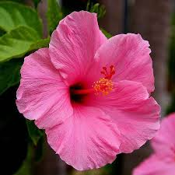

Kulala Street
Thirunainarkurichy
Ammandivilai Post
Kanyakumari District
Tamil Nadu – 629 204.

From the Director

It is with great pleasure I am submitting the annual report of Centre for Social Development for the year 2024-2025. CSD in its 33rd year of formation rededicates with the missionary zeal of improving the socio-economic status of the rural poor weaker section and socially excluded people of the community.

During the last years we have undertaken lot of activities and programs for the rural poor, artisans, women, children, youth and adolescents and socially excluded people of the community in health, sanitation, education, village industries development, holistic development of the villages, agricultural development etc. We are having transference in all of our activities.

We got ISO 9001 – 2008 for the quality services rendered by us to the target community. We are arranging for the welfare activities of the staff during the coming year.

I take this good opportunity to extend my thanks to the General Body members for their interest appropriate guidance shows towards the CSD’s activities and the development of the communities which we have interested to develop.

I am thankful to the financial supporters extended in the form of projects by Department of Science and Technology, New Delhi, DSIR, New Delhi, TANSACS, Chennai,NABARD, Chennai, KVIC Mumbai, IOCL, Chennai, RuTAG-IITM, Chennai, TANSACS, Chennaietc. for their timely financial supports for us for implementing our projects.

I gratefully acknowledge the committed services rendered by the full time and part time staff,expert’s indifferent fields,Project consultants and volunteers of CSD, the committee members of CSD etc.

I am very much thankful to our friends, well-wishers, advisers, consultants, and different Government department heads, NGOs, Banks and supporters individually and collectively for all the co-operation extended to us for our social actions.

Dr.P. Bagavatheeswaran
Director.

About our Organization

Centre for Social Development was registered as a society on 11th August 1992 under the Tamil Nadu Societies Registration Act 1975. The founder of our organization is Dr.P.Bagavatheeswaran and also the Director. From the inception onwards CSD has actively contributing to socio-economic development of the target groups in Tamil Nadu especially in Kanniyakumari, Thiruvallur, Tuticorin ,TenkasiandTirunelvelidistricts.

Vision

Preserving and promoting the local indigenous cultural heritage, harmony and artisan skills of the people and empowering socio-economically the weaker sections and discarded people of the society towards an egalitarian society.

Mission

Facilitating the grassroots,dalits, artisans, orphans, affected and infected children, rural youth both male and female, women in distress of their dilapidated conditions, rehabilitate and empowering them both socially and economically through specialize staff team and suitable activities.

Objectives

- To improve the health standard of people, safeguarding hygiene and environment safety.
- To rehabilitate the weaker section, depressed communities, socially excluded, artisan, child labor and bonded labor.
- To develop and establishing viable and sustainable income generation activities using locally available resources.
- To provide infrastructural facilities with effective construction techniques to the rural poor and depressed communities.
- To conduct community development programs for tribal, youth, schedule caste and differently-abled people.
- To provide care and support services to the needy people.
- To identify the potential entrepreneurs among the rural people/youth and guide them towards socio economic development.
- To help the entrepreneurs for the establishment of their own sustainable units.
Target Group

CSD is concentrating on the economically weaker sections of the society viz.

  - Scheduled castes / tribal.
  - Landless laborers and marginal farmers
  - Village artisans / crafts person
  - Adolescents, Youth, Women and children
  - Migrants, Female Sex Workers (FSW), Men Sex with Men (MSM)
  - Minority communities
  - Potential entrepreneurs
  - Widows, destitute, old age people etc.
  - PLHA and HIV affected and infected.
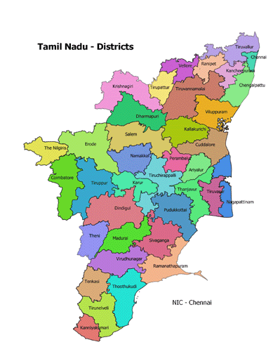
Working Area Map
Kanyakumari
Tirunelveli

Addresses of CSD’s Branch Offices:
- CSD, CSD,
20/47 Salt Merchant compound Thumbavilai.
Near Thuckalay Bus stand, Thalakulam PO,
Thuckalay& P.O. Kanyakumari District.
K.K. Dist - 629 175.

- CSD
‘0’ Point
Pechiparai& P.O,
Kanyakumari Dist.

Director’s Awards towards CSD’s achievement.
- Best Rural Artisan Award.
- Man of Winner Award.
- Anna Award.
- Annai Indira Gandhi Award &SevaiChemmal Award.
- Bharatharatna Dr. M.G.R. Award.
- Jambavan Award.
- Bharathi Award.
- AnnaiTherasa Award.

Thanks to Dignitaries

.
Dr.Ranjeet Bairwa - Scientist, DSIR, New Delhi.
Dr.Rajinder Singh - Scientist, DST-NCSTC, New Delhi
Dr. InduPuri - ScientistDST, New Delhi.
Dr. Rajni Rawat - Scientist, DST, New Delhi
Dr. Anuradha Pughat - Scientist, DST, New Delhi.
Dr. Konga Gopikrishna - Scientist, DST, New Delhi.
Dr. Abhijit Deshpande - Scientist, IITM, Chennai
Shri. Arif Mohd - Azim Premji Philanthropic Initiatives Private
Limited, Bangalore.

Thanks to Resource Persons
Dr. S.Anandhakumar - Scientist, NIIST, Trivandrum.
Dr. T.K Mukhapodayay - Retd. Scientist, CGCRI Calcutta.
Mr.Yad Ram - Rtd. Technical Officer, CGCRI. Khurja
Dr. Jeyanandan - Rtd. Veterinary Doctor, Goat Research Station, Kerala.
Our Appreciable Master and Technical Team

Dr. P. Bagavatheeswaran - Pottery Expert
Dr.A.D. Shobana Raj - Environment Scientist.
Mr. Laxmikant - Pottery Technician
Mrs. R. Baby LeelaBai - EDP Trainer
Mrs.R. Mary Stella - SHG Trainer
Mr.S.Arul Monoharan - Youth Trainer.
Er.B. Karthik - Research Scholar.
Our Sincere Bankers

Union Bank of India - Vadasery,Nagercoil and Kadiyapattanam.
Bank of Baroda - Nagercoil
Indian Bank - Muttom
State Bank of India - Thingal Nagar
ICICI Bank - Marthandam
Our networking with

TNVHA - Tamil Nadu Voluntary Health Association.
SAM - Social Action Movement
INN - Indian Network of NGOs – HIV/AIDS Network.
IHN - Initiatives of HIV/AIDS – Net.
CACL - CampaignAgainst Child Labour
cHAI - Consortium on Health Awareness in India.

HIGH LIGHTS DURING THIS YEAR 2024 – 2025

1. HIV/AIDS Prevention and Care Continuum changed the
behavior of HRGs and improve the health status.

Achievement for the year 2024-2025
Under this project CSD has conducted targeted intervention among Female Sex Workers (FSWs) and Men having sex with men (MSMs) in Kurunthencode,
Thuckalai, Munchirai, Killioor, and MelpuramBlocks of Kanyakumari District with the help of TANSACS, Chennai. This is a continuous project. 700FSWs and500MSMswereidentified and rendered services to them.
Achievement from April 2024 to March 2025.
 |  | APR | MAY | JUNE | JULY | AUG | SEP | OCT | NOV | DEC | JAN | FEB | MAR | TOTAL
NEW ID | FSW | 7 | 7 | 23 | 10 | 0 | 18 | 1 | 11 | 0 | 13 | 12 | 24 | 126
NEW ID | MSM | 2 | 2 | 14 | 12 | 1 | 16 | 8 | 2 | 1 | 4 | 4 | 42 | 108
HIV | FSW | 63 | 93 | 130 | 83 | 83 | 216 | 90 | 128 | 87 | 61 | 144 | 106 | 1284
HIV | MSM | 51 | 77 | 92 | 76 | 55 | 98 | 56 | 64 | 76 | 53 | 79 | 93 | 870
STI | FSW | 108 | 129 | 185 | 103 | 160 | 202 | 167 | 184 | 113 | 151 | 104 | 183 | 1789
STI | MSM | 78 | 75 | 117 | 94 | 60 | 88 | 97 | 90 | 84 | 82 | 84 | 186 | 1135
VDRL | FSW | 45 | 72 | 130 | 83 | 83 | 201 | 90 | 112 | 78 | 61 | 144 | 106 | 1205
VDRL | MSM | 37 | 29 | 106 | 76 | 55 | 83 | 56 | 59 | 54 | 53 | 79 | 93 | 780
Condom Demand | FSW | 12401 | 11652 | 11390 | 11208 | 11208 | 11208 | 11320 | 11320 | 11324 | 11324 | 11324 | 11346 | 137025
Condom Demand | MSM | 8970 | 8946 | 11394 | 7412 | 7412 | 7412 | 7412 | 7412 | 7460 | 7460 | 7460 | 7560 | 96310
Condom Distribution | FSW | 4013 | 6918 | 8304 | 7530 | 11234 | 6932 | 11310 | 11282 | 9100 | 0 | 0 | 11332 | 87955
Condom Distribution | MSM | 2694 | 4807 | 8239 | 5988 | 7236 | 4184 | 7622 | 7246 | 6176 | 0 | 0 | 7069 | 61261
Counselling | FSW | 56 | 78 | 107 | 90 | 103 | 123 | 78 | 77 | 89 | 67 | 123 | 111 | 1102
Counselling | MSM | 59 | 48 | 67 | 45 | 62 | 84 | 43 | 56 | 41 | 56 | 74 | 59 | 694

The core group community people to be highly vulnerable for STI and HIV infections due to their unsafe sex behaviors. During this year One HIV/AIDS affected person (FSW) were identified and follow up services provided to the person. Ten peer educators, four outreach workers, a Counselor, a Monitoring and Evaluation officer and a Project Manager worked in this project. This project was sanctioned and started from 01.04.2012 onwards.
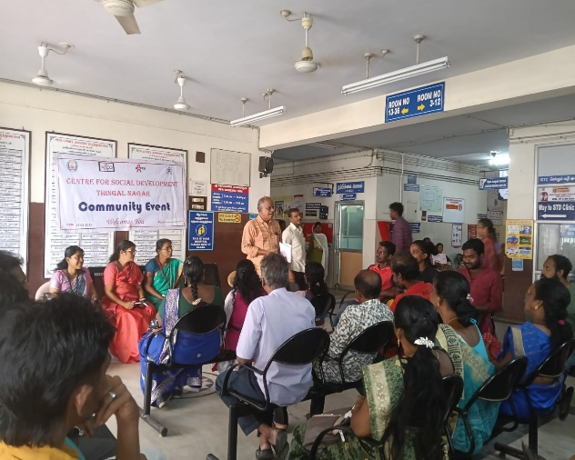
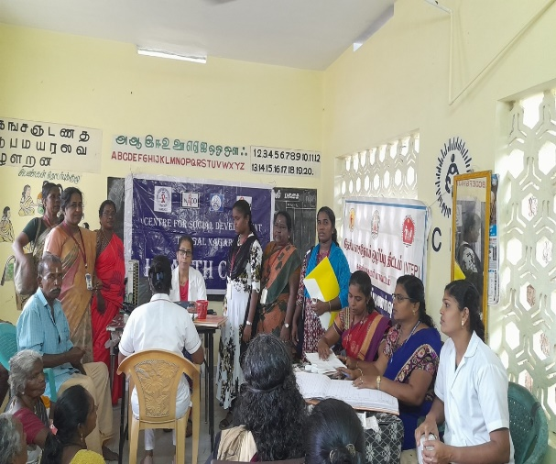

Community event Health Camp
Special events

S.No | Name of the event | Date of event | Place of event | No. of participants
1 | Health Camp | 26/6/2024 | Muthalakuruchi | 35
2 | Advocacy Activities | 29/8/2024 | Padmanabhapuram GH | 9
3 | Community Event | 28/09/2024 | Padmanabhapuram GH | 92
4 | Health Camp | 13/11/2024 | Killiyoor PHC | 79
5 | Advocacy Activities | 21/02/2025 | Chunkankadai | 16
6 | Health Camp | 20/03/2025 | TI Office, Thuckalay | 87
7 | Community Event | 14/03/2025 | Padmanabhapuram GH | 70
8 | Advocacy Activities | 19/03/2025 | Mondaymarket | 15

Attending training programme

S.No | Name of the training | Date | Place | No. of participants
1. | SOCH Training | 11.03.2025 to 12.03.2025 | TNeGA ,PT Lee Building , Anna salai, , Chennai-02 | M&E

- SHG promotion activities.
Organizing the rural women into group is one of the major activities of CSD. Under this programme both Kanyakumari and Tirunelveli Districts were covered. Regular meetings were conducted by our selected Animator in different locations of the district. The following table shows the details of the SHGs promoted.

Details of SHGs – Kanyakumari and Tirunelveli Districts
Name of the District | No. of SHGs | Total Savings | Bank Loan
Tirunelveli | 98 | 2,65,05,500 | 42,00,000
Kanyakumari | 73 | 3,95,15,000 | 87,00,000
Total | 171 | 6,60,20,500 | 1,29 ,00,000

- CSD-SHG Federation

CSD promoted the SHGs were federated and registered under the Tamil Nadu Societies Registration Act under the name of CSD-SHG Federation. At present the federation consisted of 11 members in Executive Committee and 230 members in General body. Both the general and executive committee meetings were conducted regularly for discussing the day to day activities of the SHGs. Programs such as future plan of Action, collection of savings, loan distribution and due collection, Bank Deposits, common programs were discussed. Programs like World AIDS Day, Women’s Day etc. were celebrated during this year.
- ICICI microfinance activities.

This is one of the major activities undertaken by CSD in extending microfinance to the SHGs working under the institution. Under the programmeboth the districts were covered. All the linkages were made to promote micro enterprises being developed by SHG women members.

Name of the District | No. of SHGs | Total loan disbursement
Kanyakumari | 29 | 2,54,00,000
Tirunelveli | 29 | 2,14,30,000
Total | 58 | 4,68,30,000

- AatharavooKaigal- Helping Hand

AtharavooKaigal is another wing of CSD, formed by the Staff members of CSD and other well-wishers of the community. The main objective of the forum is to help the PLHAs, HIV affected and economically weaker sections of the society. These beneficiaries were selected from the SHGs of the respective villages. During the financial year the following assistances were distributed to the eligible candidates.

- Distribution of note books and uniforms to 12 PLHIV, deserving and orphan students of the targeted areas.
- Nos. of Widows from the BPL were provided with financial support for promoting their business for income generation.
- Provided Economic and livelihood help to PLHIVs and HRGs.

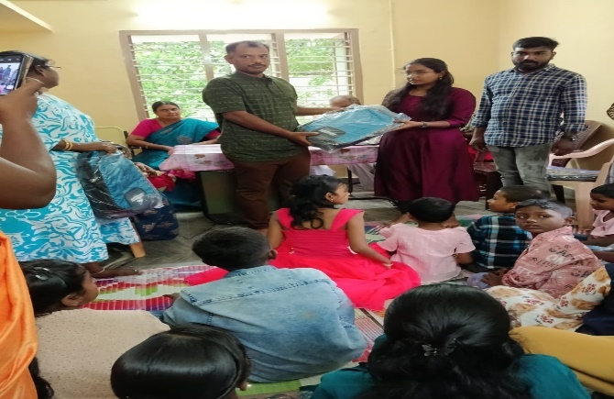
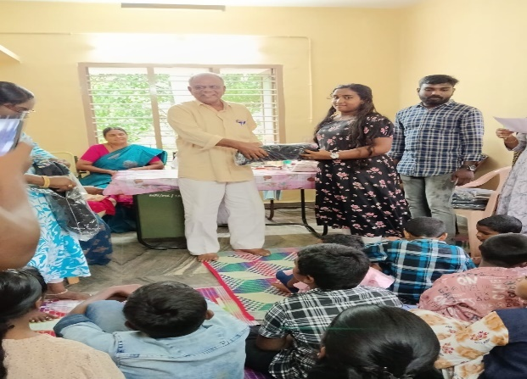

- Pottery Resource Centre at Thalakulam

The resource centre at Thalakulam has done remarkable research activities related to development of pottery. Some of the innovative activities carried out during the years were listed as follows:

- This centre has been utilized for extending training to the potters as well as entrepreneurs who are willing to establish sustainable pottery units.
- Clay composition of different nature has been tested for fabricating quality products.

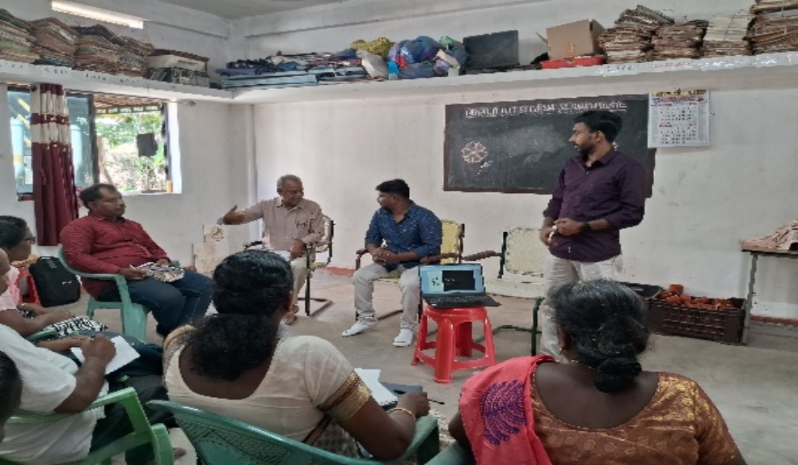

- CSD’s Other General Activities

In addition to the socio-economic empowerment activity CSD is concentrating social service activities to the target people is also given importance. So many social service activities promoted by Govt. schemes had been availed to target people through mobilizing the SHGs to negotiate with the respective departments. The following were the important social activities made for this financial year in Kanyakumari and Tirunelveli Districts.
- Arranging Pension for Widows and aged persons.
- Arranging to get Ration Card.
- Seedlings for planting trees.
- Awareness about hygienic and diseases.
- Quit plastics and save our earth.
- Conducted exposure visit to the school, college students and vocational
trainees.
Independence Day and Republic day Celebration
CSD was celebrated Independence Day and Republic day Celebration in our Thalakulam Field Office.
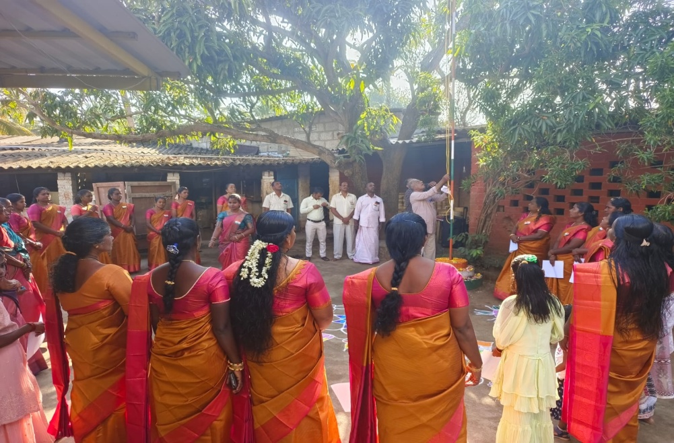

Republic day celebration at Thalakulam
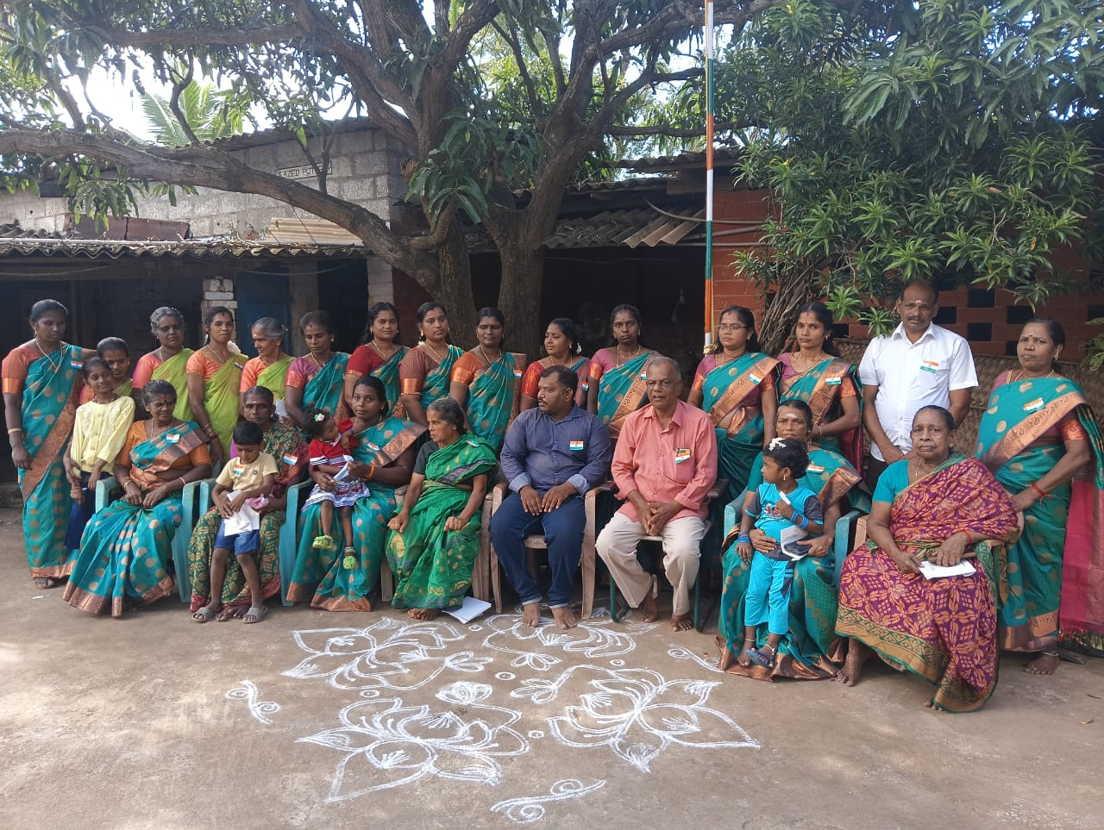

Independence day celebration at Thalakulam

Annual General Body Meeting.
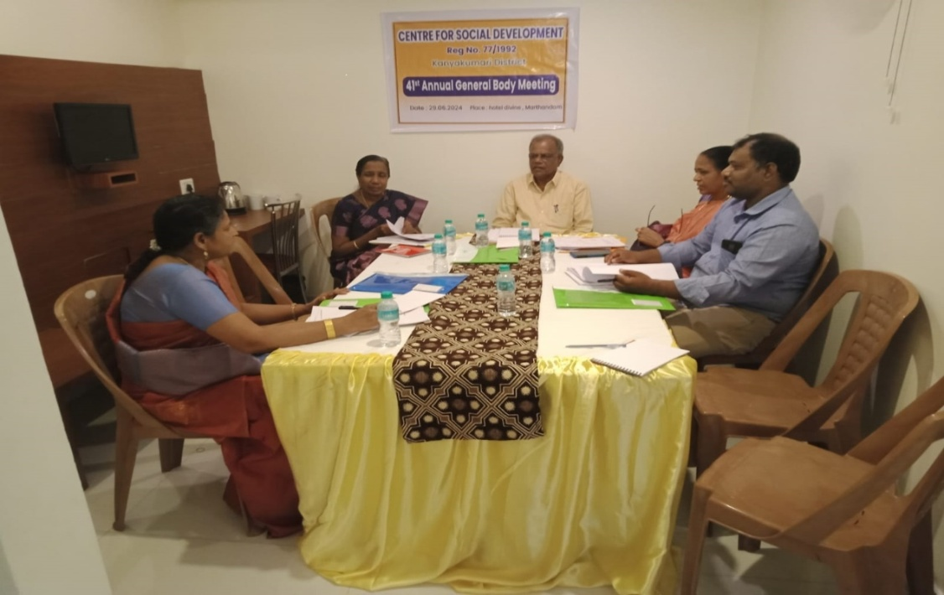

General Body Meeting
41st Annual general body meeting was conducted at Hotel Divine, Marthandam on 29.6.2024. The Annual report and Audited report were discussed in the meeting.

CSD’s G.B. Members List

S.No | Name of Members | Address | Occupation | Position in the Board
1. | Dr.A. Anandhy | 23D/10-4A, Grace Near High land Avenue,  ScottNager, Nagercoil. | Lecturer | President
2. | Dr.P.Bagavatheeswaran | Kulala Street,  Thirunainarkurichi, Ammandivilai Post,  K.K.Dist. | Ceramic Consultant | Secretary
3. | Mrs. R. Baby LeelaBai | Kadanthancode,  Kuzhithurai P.O.  K.K.Dist | Project Co-ordinator | Treasurer
4 | Mrs.B.SunandaGnanaBai | PremIllam  Kadanthancode  Kuzhithurai P.O  Kanyakumari District,  Pin 629 163. | Bank Manager(Rtd.) | G.B.Member
5 | Mrs.G. GnanaSelvi | PuthuvilaiVeedu,  Kanjampuram P.O,  Kanyakumari District | Teacher | G.B.Member
6 | Mr.B.Karthik | 11/32A Kulala Street,  Thirunainarkurichi,  Ammandivilai 629 204,  K.K.district,Tamil Nadu | Asst. Director | G.B. Member
7 | Dr.S. Sreeji | 136 S.J. Bhawan,  Kadanthancode  Pacode  Kuzhithurai 629 163,  K.K.Dist, T.N. | Lecturer | G.B. Member

Note: All the General Body members of the organization are honorary and they are not receiving any remuneration from the organization.

Consolidated Financial Status

Assets & Liabilities of the year 2024-2025

Liabilities | Amount | Assets | Amount
Capital Fund | 46,29.900.98 | Cash in Hand & Bank | 2,49,914.34
Liabilities & Advance A/c | 11,51,768.00 | Fixed Assets | 43,81,548.00
 |  | Deposits & Advance | 1,38,357.00
 |  | TDS | 2,53,444.16
 |  | Grant Receivable | 7,58,405.48
 | 57,81,668.98 | Total | 57,81,668.98

Income & Expenditure for the year 2024-2025
Income | Amount | Expenditure | Amount
Grant | 25,96,231.00 | Program Expenses | 34,46,181.56
Others | 10,59,116.00 | Depreciation | 6,28,012.00
Interest | 1,693.04
Expenditure over income | 4,17,153.52
Total | 40,74,193.56 | Total | 40,74,193.56
,

Conclusion
Our institution’s activities are going on well and progressively increasing. All our activities are technology based and Charity Oriented. We are having well experienced experts in different fields and also close contact with most of the research and Training institute in the country. In future our institution is planning to incorporate with more funding agencies and well-wishers and extending our working area with charitable nature and development programs for poor people and depressed communities and to achieve our goal by the GRACE OF GOD.

Thank you.

